Exam 3: NE591-10: Nuclear Fuel Performance

1. The temperature and gap width of a fuel pellet, as predicted by a fuel performance code, is shown below. Using the plots as your guide, determine what is currently occurring within the cladding, gap and/or pellet at each number. Note that the numbers are at the same burnups on the two plots. (15 pts)

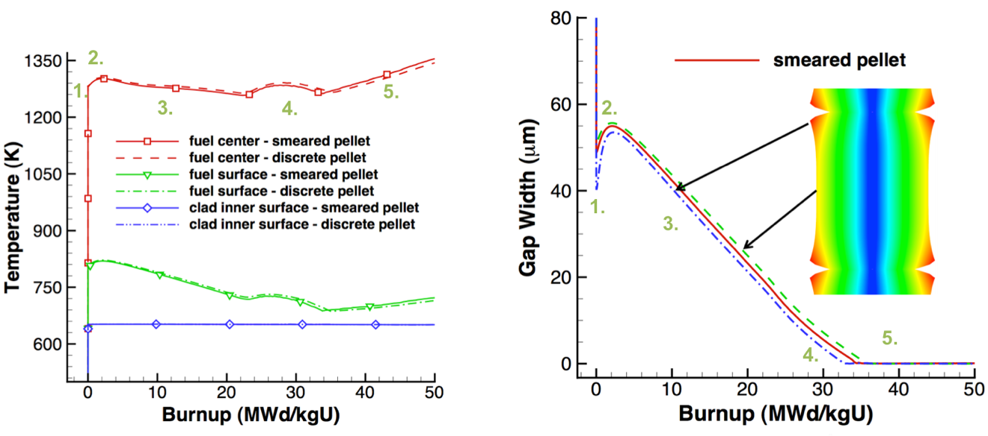

For each number (1-5), describe what is occurring in the cladding, gap, and pellet. Also, describe what features in the plots indicated these behaviors.

1. The fuel heats up, causing thermal expansion in both the fuel and the cladding. This decreases the gap width.

2. The fuel densifies, causing the gap width to increase and causing the temperature to increase.

3. The fuel swells and the cladding creeps down, decreasing the gap width. This causes the temperature to decrease.

4. The fuel continues to swell and the cladding to creep down, but fission gas is also being released into the gap, causing the temperature to go up before continuing downward.

5. The fuel and cladding have come into contact. The gap thickness stays zero from now on, but the temperature steadily rises due to the decreasing thermal conductivity of the fuel.

1. A fuel pellet with an average grain size of 8 microns is irradiated with a volumetric neutron flux of 2.0e13 fissions/(cm3-s). Assume the pellet is at a uniform temperature of 900°C.
2. What is the fission gas diffusion coefficient at this temperature? (5 pts)

T = 900 + 273 = 1173

D1 = 7.6E-6*exp(-3.03/(kb * T) ) = 7.28e-19

D2 = 1.41E-18 * exp(-1.19/(kb * T) ) * sqrt(frate) = 4.82e-17

D3 = 2E-30 * frate = 4.0e-17;

**D = D1+D2+D3 = 8.9e-17 cm2/s**

1. How many gas atoms/cm3 are released from the fuel after 2 years of irradiation? Assume the yield y = 0.3017. (5 pts)

t = 2*365*24*3600 = 6.307E7 s; y = 0.3017

gas_produced = t*y*frate = 3.81E20 gas atoms/cc

tau = D*t/a^2 = (8.9E-17)(6.307E7)/(8E-4)^2 = 0.0088 , tau < pi^-2

f = 4*sqrt(D*t/(pi*a^2))-3/2*D*t/a^2 = 0.211- 0.013 = 0.198

**gas_released = gas_produced*f = 7.54E19 gas atoms/cm3**

1. The pellet is removed from the reactor and from its cladding, venting all released gas. It is then moved to a furnace and annealed at 2000 °C. Estimate how long before 60% of the gas trapped in the pellet is released. Assume τ > π-2. (10 pts)

T = 2000 + 273.15 = 2273.15 K (1 pt)

D1 = 7.6E-6*exp(-3.03/(kb * T) ) = 1.45E-12

D2 = 1.41E-18 * exp(-1.19/(kb * T) ) * sqrt(frate) = 1.4501E-14

D3 = 2E-30 * frate = 4.0E-17;

D = D1+D2+D3 = 1.4701E-12; (3 pts)

Frac = 0.6 = 1 – (6/pi^2)exp(-pi^2*Dt/a^2)

Ln(0.658)=-pi*(1.395*10^-10)*t

**T = 9.6*10^8 s, 30 yrs**

1. A ZIRLO cladding tube is in reactor at 600 K for one year. The initial wall thickness is 600 μm.
2. Estimate the oxide thickness after this time? (8 pts)

t* = 6.62*1-^-7 * exp(11949/T) = 295 d

delta* = 5.1 exp (-550/T) = 2.04 μm

delta = delta* + Kl(t-t*)

Kl = 7.48*10^6 exp(-12500/T) = 0.0067

**delta = 2.04 + 0.0067(365-295) = 2.51 μm**

1. Assuming the hydrogen pickup fraction is 15%, what is the weight PPM of hydrogen in the cladding after one year? Assume PBR = 1.56, ρZr = 6.5 g/cc, ρZrO2 = 5.68 g/cc. (8 pts)

f = 0.15;

dens_oxide = 5.68; %g/cm3

dens_zr = 6.5; %g/cm3

fo = 32/(91+32) = 0.2602

MH = 1;

MO = 16;

CH = 2*f*delta*dens_oxide*frac_o*MH/MO*1E6/((t_clad-delta/1.56)*dens_zr)   
**CH = 2*0.15*2.51*5.68*(32/123)*(1/16)/((600 – 2.51/1.56)*6.5) * 10^6 = 17.9 wt ppm**

1. Determine the total change in the fuel volume given: αth=11x10-6, fission rate = 3.5x1013 fiss/cm3-s, T=1600 K, Tref=300 K, Δρ0=0.01, BD=5 MWD/kgU, ρ(UO2)=10.97 g/cc, t=85 days. (15 pts)

eps_tot = eps_th + eps_d + eps_sfp + eps_gfp

eps_th = (11*10^-6)(1600-300) = 0.0143

B = frate*t/Nu; Nu = 10.97/270 * (6.022*10^23) = 2.44*10^22 atoms U

t = 85*24*3600 = 7.34E6; B = (3.5E13)(7.34E6)/(2.44E22) = 0.0105

eps_d = 0.01(exp(0.0105*ln0.01/0.0053)) = -0.01

eps_sfp = 5.577E-2 *rho*B = (5.77E-2)(10.97)(0.0105) = 0.0064

eps_gfp = (1.96E-28)(rho*B)(2800-T)^11.73 * exp(-0.0162(2800-T))exp(-17.8*rho*B)

eps_gfp = (1.96E-28)(0.115)(2800-1600)^11.73 * exp(-0.0162(2800-1600))exp(-17.8*0.115)

eps_gfp = 0.0138

**eps_tot = 0.0143 – 0.01 + 0.0064 + 0.0138 = 0.0245**

1. What are the five types of fission products that form in the fuel? (5 pts)

Soluble oxides, insoluble oxides, metallic precipitates, volatiles, noble gases

1. List the three stages of fission gas release. (6 pts)

* gas atom production and diffusion to grain boundaries
* gas bubble form on grain boundaries, grow and interconnect
* gas bubbles fully interconnect (percolate) releasing gas along grain boundary pathways

1. Name two types of creep. Which type of creep is based on bulk diffusion? (5 pts)

Nabarro-Herring, Coble, Dislocation, Irradiation. N-H is based on bulk diffusion.

1. What performance effects result from the High Burnup Structure? (6 pts)

Retains more fission gas, increased toughness, higher thermal conductivity

1. Describe the concept of microstructure-based fuel performance modeling. (6 pts)

Instead of utilizing empirically fit correlations to experimental datasets, utilizing fundamental physics to describe underlying material mechanisms and properties to describe and predict microstructural evolution, which leads to description and prediction of macroscopic properties.

1. List three benefits of using Zr cladding. (5 pts)

Neutron transparent, good corrosion resistance, resistance to void swelling, adequate mechanical properties, good thermal conductivity, affordable, widely available

1. Why does metallic fuel undergo constituent redistribution? (5 pts)

A combination of thermodynamic and kinetic factors. The phase diagram has different Zr solubilities in different U phases present in U-Zr fuel, and Zr wants to diffuse up the temperature gradient (Soret diffusion), leading to an enrichment of Zr in the center of the fuel slug.

1. Why is the microstructure of U-Zr based fuels so varied and complex? (6 pts)

Similar to question 11, a combination of thermodynamic and kinetic factors. The phase diagram points towards a number of phases being present within the system due to the composition and temperature regime of the fuel. In addition to the radially temperature gradient, an axial temperature gradient is also present, leading to variable microstructures along the length of the fuel rod. Finally, fission products can precipitate out or diffuse to the fuel periphery, leading to unique microstructural features.